Tall Paul Volcker, The Last Central Banker---R.I.P.(Part 1)
From: https://davidstockmanscontracorner.com/tall-paul-volcker-the-last-central-banker-r-i-p-part-1/
By David Stockman. Posted On Monday, December 9th, 2019
There can't actually be a good central banker in this day and age, let alone a great one, because in a world of abundant digital and bank ledger money central banks really aren't much needed (see Part 2).
Still, given the inherent dangers of the modern central banking institutions with which we are apparently stuck---at least until the Great Reckoning and Reset---Paul Volcker was the greatest central banker of all. That's because he understood the acute limitations and dangers of the very institution over which he so famously, courageously and constructively presided.
Indeed, as he reflected in 1994 after four decades in the maelstrom of Wall Street and Washington,
It is a sobering fact that the prominence of central banks in this century has coincided with a general tendency towards more inflation, not less. [I]f the overriding objective is price stability, we did better with the nineteenth-century gold standard and passive central banks, with currency boards, or even with “free banking.” The truly unique power of a central bank, after all, is the power to create money, and ultimately the power to create is the power to destroy.
The bolded sentence says it all. From Greenspan forward, our central bankers virtually to a man and woman have seen themselves as tantamount to a divinely-inspired Committee to Save the World---the very opposite of Paul Volcker's fraught institution possessing the power to destroy capitalist prosperity in the name of doing good.
So on the occasion of Volcker's passing, the question recurs: Did something profound happen in August 1987 when Tall Paul handed the baton to Alan Greenspan and his heirs and assigns?
By our lights, the answer is unequivocally and decisively, yes.
In fact, Volcker was the last central banker in the old-fashioned sense of viewing the Fed's remit narrowly as Carter Glass and the 1913 framers had intended. That is, its job was to provide liquidity, reserves and a stabilizing rudder to the commercial banking system.
Beyond the boundaries of the latter, however, stood the realm of honest price discovery in the marketplace of finance. What happened out there in terms of bond yields, stock prices and main street saving and borrowing trends was the business of market capitalism to determine; they were not outcomes to be fostered by the quantitative targets and edicts of the FOMC.
By contrast, Greenspan and his successors were not even central bankers. They were monetary central planners who attempted to micromanage not just the commercial banking system, but the entire aggregate of national economic activity and its principal variables---inflation, GDP, employment, business investment, consumer spending etc.
And they did so based on essentially Keynesian macro-models which erroneously presumed that central banking tools fit for supplying reserves and stabilizing liquidity to the commercial banking system were also suitable for the task of Keynesian macro-management of the entire main street economy.
Self-evidently, they are not---and that's the fatal error which has been progressively poisoning capitalist prosperity ever since Tall Paul left the Eccles Building 32 years ago.
To be sure, Volcker was rightly acclaimed for his victory over the goods, services and commodity inflation of the 1970s, but what he actually accomplished was far more fundamental and enduring, albeit completely lost in the subsequent detour of the Greenspanian apostasy.
To wit, he vindicated the Fed's capacity to discipline the excessive creation of old-fashioned bank credit by withholding the supply of new reserves to the system. And that mattered at a time when so-called high powered bank reserves mattered, which is no longer the case, as we will essay in Part 2.
Indeed, after Nixon cut the anchor to gold, the Eccles Building under the spineless Arthur Burns and the mindless William Miller turned the Fed's reserve spigot wide open and before long bank credit creation was off to the inflationary races.
As shown in the chart below, during the eight years between the Fed's unshackling at Camp David in August 1971 and Volcker's appointment as Fed Chairman in August 1979, loans and securities held by the domestic banking system (purple line) exploded at a previously unprecedented and unimaginable rate of 11.0% per annum.
That caused nominal GDP (green line) to follow suit and rise by 10.6% per annum---since in the initial instance this massive upwelling of credit fueled a surge of economic activity and purchases. But this was before the rice paddies of China had been mobilized and brought into the global trading and labor supply system by the Red Ponzi; and, in fact, upwards of 40 million Chinese peasants had perished from starvation during the previous decade and one-half owing to Mao's insane Great Leap Forward and Cultural Revolution.
So inflationary monetary policy at the Eccles Building back then fostered virulent domestic cost, wage and price inflation because there was no material amount of lower cost capacity in Europe or even Japan to absorb the roaring US demand. Indeed, 10.6% spending growth for eight years running--notwithstanding a deep recession in 1974-1975---was a veritable hatchery for runaway prices.
As it happened, real GDP (red line) rose by 3.5% per annum, absorbing about 33% of the nominal spending explosion that had been fueled by the Fed's reckless injection of new reserves into the banking system. But that left 67% of the spending gain (i.e. nominal GDP) to well-up in the form of soaring prices and wages.
Stated differently, two-thirds of the massive monetary inflation of that eight year interval ended up in the commodity indexes, the CPI and the GDP deflator. The former rose by 9.0% and 9.1% respectively, while the GDP deflator (brown line) rose by nearly 7% per annum.
And it was this runaway inflation train, which by all accounts was heading for double digits in the fall of 1979, which caused Jimmy Carter---even though surrounded by card-carrying Keynesian economists in the White House and departments---to draft Paul Volcker, an old-fashioned sound money Democrat, to take over Chairmanship of the Federal Reserve.
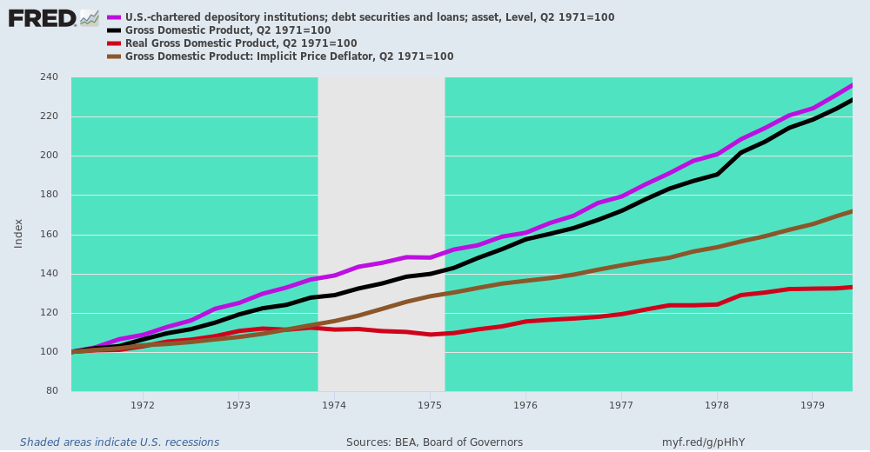
And that brings us to the essence of Volcker's monetary resolve and triumph over inflation. The latter was racing skyward in August 1979, but then Fed Chairman, former golf cart manufacturer and Carter appointee, William Miller, had been convinced by Washington's reigning Keynesian economists that the Fed had to accommodate at least the existing level of inflation in its monetary growth targets.
This meant, of course, that the US economy was on an accelerating treadmill, racing toward double-digit consumer inflation and a renewed blow-off top in oil and commodity prices.
But at the meeting with Jimmy Carter when Volcker accepted the job, he warned the US president that the days of Easy Money were coming to an abrupt end by famously referencing his differences with his predecessor. As per the New York Times,
Meeting Mr. Carter in the Oval Office, Mr. Volcker slumped on a couch, a familiar cigar in hand, and gestured at Mr. Miller, who was in the room. “You have to understand,” Mr. Volcker said he told the president, “if you appoint me, I favor a tighter policy than that fellow.”
And that's exactly what he did. Soon thereafter Volcker announced that the Fed would sharply curtail the rate of reserve injections into the banking system in order to rein-in runaway credit growth and bring domestic spending and inflation to heel.
The proof is in the pudding per the chart below. The chart appears clinical, but actually represents a profound act of policy discipline.
Between Q3 1979 and Q1 1982, Volcker ratcheted back the growth rate of the Fed's balance sheet (purple line) to just 3.24% per annum during an interval when inflation was hitting a double-digit blow-off top. In fact, even the GDP deflator (brown line) rose at an 8.60% annual rate during the period.
Consequently, the Fed's inflation adjusted balance sheet shrunk by an incredible 12% during that 2.5 year period, which, in turn, brought credit growth and speculative spending to a screeching halt.
Needless to say, Volcker was roundly reviled in the Imperial City for the brutal monetary math embedded in the chart below. While the Gipper always supported Volcker during this period of trial by fire and brutal recession, that did not extend to most of the White House advisors and virtually all of the GOP leadership on Capitol Hill, who had been happy to denounce Jimmy Carter's double-digit inflation but not the unavoidable cure that Tall Paul brought to bear during 1980-1982.
At one meeting in the Cabinet Room with the GOP leadership, in fact, we well remember Senate GOP leader Howard Baker virtually shouting that Volcker had to get his big fat foot off the neck of American business or be removed from office.
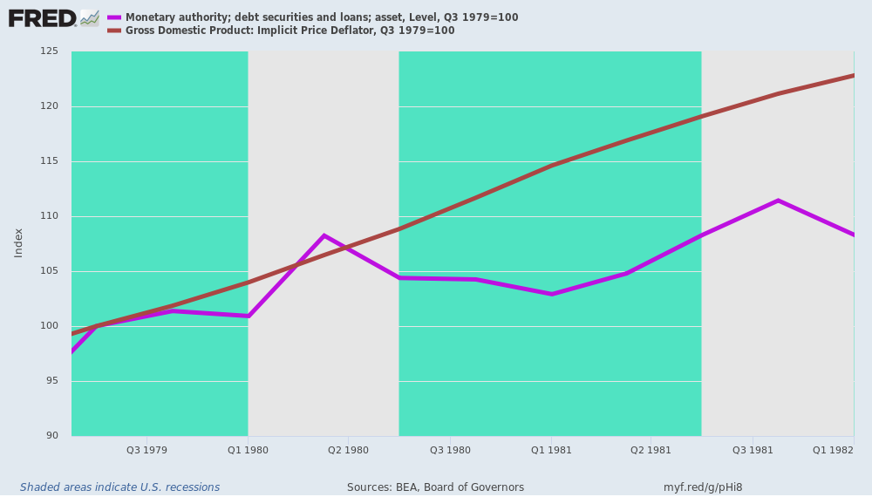
Volcker preserved anyway, and the victory over inflation came with dramatic alacrity. After peaking at a 14.6% year-over-year rate in March 1980, the CPI increase rate fell to 10.6% in the spring of 1981 and to just above 3.0% by the end of 1982.
At the time, there wasn't more than a corporal's guard of PhDs who believed inflation could be slain with such dispatch. The theory was that it had somehow become embedded in the wage/price/cost structure of the domestic economy and that it would take years, if not decades, to purge.
Not at all. The destructive inflation reflected in the chart below was not a mysterious economic illness. Nor was it a reflection of the so-called Phillips Curve, as was so vehemently insisted upon by professional economists at the time.
To the contrary, what was actually embedded in the era's roaring inflation was the wrong headed monetary policies being conducted in the Eccles Building; it was a painful real life demonstration of the printing press' power to destroy, as referenced in the quote above from Paul Volcker.
His greatness, therefore, lies in the fact that he understood that what was failing was not capitalism, but the central bankers who had fecklessly tried to "stimulate" a better economic outcome than the free markets were producing on their own.
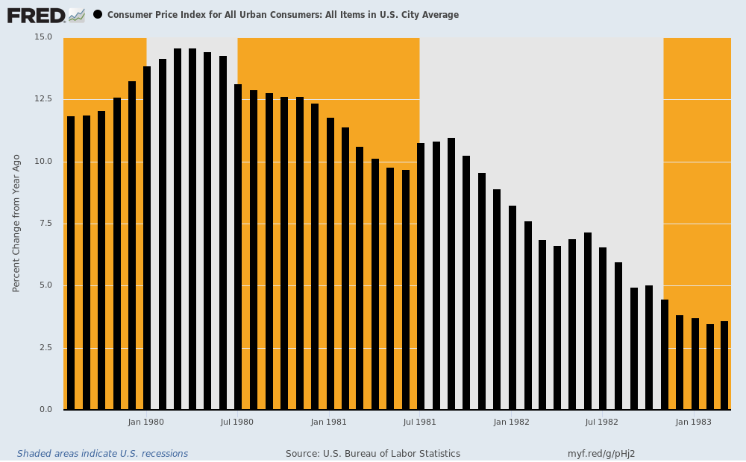
As we noted in the Great Deformation, Volcker "did not...dream of levitating the economy through the "wealth effect' or by coddling Wall Street speculators" per the modus operandi of today's monetary central planners.
Indeed, by permitting short-term interest rates to soar above 20% as he choked off the supply of new reserves to the banking system, Volcker actually monkey-hammered the carry-trades which are at the heart of Wall Street's speculative games.
After all, even though the 10-year benchmark Treasury yield touched on 16% during that period, nobody was buying it because they could fund their position with 20% overnight money.
And that was the real reason that Volcker was the greatest central banker: He saw his job as insuring sound money and financial discipline and stability, not pleasuring the crybabies and bullies of Wall Street.
As we further suggested in the above referenced book, the heart of Volcker's success was in destroying the illusion that there was a one-way bet on inflation and central bank accommodation thereof. But as we will address in Part 2, fostering that destructive delusion is exactly the sin which lies at the core of Keynesian monetary central planning and which has become the modus operandi of the Fed after Tall Paul left the scene:
Volcker accomplished this true anti-inflation objective with alacrity. By curtailing the Fed’s balance sheet growth rate to less than 5 percent by 1982, Volcker convinced the markets that the Fed would not continue to passively validate inflation, as Burns and Miller had done, and that speculating on rising prices was no longer a one-way bet.
__________________________________________________________________________________

Tall Paul Volcker, The Last Central Banker---R.I.P. (Part 2)
From: https://davidstockmanscontracorner.com/tall-paul-volcker-the-last-central-banker-r-i-p-part-2/
By David Stockman. Posted On Tuesday, December 10th, 2019
The old saw that no good deed goes unpunished went into overdrive in the case of Volcker's stunning 1980-1982 conquest of runaway inflation. That victory paved the way for a galloping recovery of GDP and jobs, which, in turn, enabled the 1984 GOP campaign slogan of "Morning in America" and the Gipper's sweeping re-election that fall.
Thus, the CPI (purple line) had dropped from a 14.6% year-over-year increase in Q1 1980 to just 2.5% by Q2 1983. At the same time, real GDP growth (brown line) catapulted out of the 1982 recession bottom to hit a 3.3% gain during the same quarter--even as it was on its way to a sizzling year-over-year gain of 8.6% in Q1 1984.
By the Q4 1984 election period, the US economy had been turned upside down. It made Ronald Reagan's 1980 campaign slogan ("Are you better off now than you were four years ago?") almost Delphic in its premonition of the four years ahead, even as it had reminded voters back then of the economic misery that Carter and the pre-Volcker Fed had instigated during 1977-1980.
To wit, during Q4 1980, the real GDP growth rate had posted at -0.04% and CPI inflation had clocked-in at +12.4% versus prior year.
By contrast, during Q4 1984, real GDP posted at +5.6% while CPI inflation had plunged by more than two-thirds.
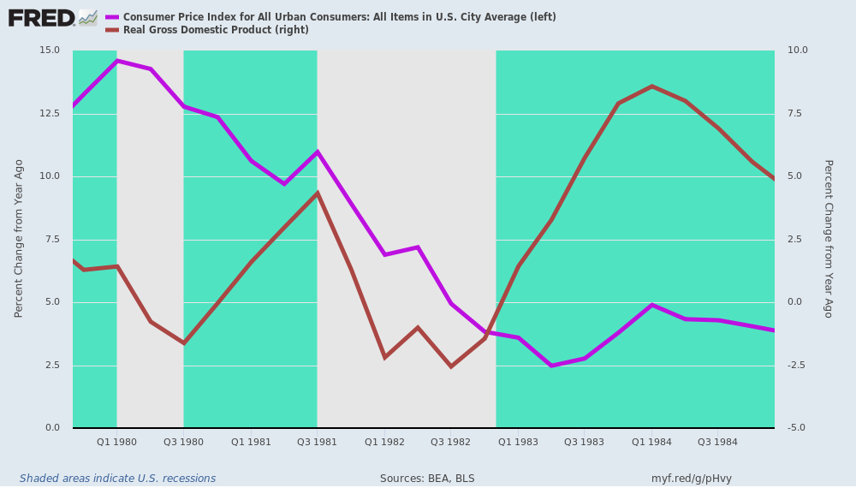
Alas, the no good deed part of the story struck shortly thereafter. The surging rebound in real output and jobs was due to Volcker's purge of inflation and the resulting curtailment of wasteful speculation in commodities and inflation hedges. But the White House advisors and GOP pols claimed it was all due to the tax cuts, which, in fact, had been neutralized by the US Treasury's heavy borrowing during 1982-1985.
At the same time, the dramatic restoration of sound money in the US proved to be potent tonic on the foreign exchange markets, which by then had been floating for more than a decade---with currency pairs bobbing wildly on a short run basis.
For instance, the dollar's exchange weighted value against major currencies stood at 106.5 in Q3 1975 after the deep 1974-1975 recession ended, but plunged by nearly 12% to 94.0 by Q3 1979 at the time Volcker was called to the rescue. Then by Q1 1981 it had rebounded to 105.3 or nearly where it had started six years earlier.
However, the revival of King Dollar was just getting started in response to Volcker's crushing of inflation and rapid progress toward restoration of sound money policies at the Fed. Accordingly, by Q1 1985 the dollar's exchange rate (blue line) had soared to 138.0, representing a 47% gain from the Carter/Miller bottom, and a 21% gain from the Q1 1982 level shown in the chart below.
At the same time, jobs growth (dark line) took on boom-like conditions after the recession ended in late 1982. So by Q2 1984, the year-over-year job gain posted at 4.5 million or +5.0% versus prior year-----a gain so large as to cause the annual gain of 1.4% during the last 12 months of the present so called-recovery to pale into insignificance.
The booming jobs part of the scenario the Reagan politicos hailed at the top of their lungs---even as they began to bellyache loudly about the soaring dollar. According to the disciples of Uncle Milton Friedman and the free market academics at the American Enterprise Institute, of course, the strong dollar was a vindication of sound money and a strong economy, and it actually was.
But the White House politico who counted far more than all the others, chief of staff Jim Baker, was having none of this theoretical nicety. He saw it as a direct threat to the booming but still nascent Reagan recovery, and simply engineered the Gipper into a private meeting with Volcker where Baker did all the talking.
As the NYT described Volcker's account of the meeting in his memoirs,
In the summer of 1984, as Reagan campaigned for re-election, Mr. Volcker was summoned to meet the president at the White House. Mr. Volcker recounts in his memoirs, published in October 2018, that Reagan sat silently while his chief of staff, James A. Baker III, delivered a blunt message: “The president is ordering you not to raise interest rates before the election.”
Mr. Volcker was “stunned,” he wrote, but he maintained his composure and left without giving a reply. He added that he had not planned to raise rates before the election, and he did not do so.
Of course, we recall well the reason for the Gipper's above referenced silence. This was a stealthy, Baker orchestrated end-run that no one else on the economics team knew anything about, and wouldn't have agreed with had we been consulted.
Nor do we think Ronald Reagan agreed with the substance of Baker's position, and was undoubtedly bamboozled into acquiescence on the assurance that Baker's edict was only a matter of short run timing.
But it wasn't. Jim Baker had the Texas disease when it came to economics.
The touchstone of the latter was a cheap currency and low interest rates---a position that had been advocated by every notable Texas politician in modern times. For instance, Nixon's Treasury Secretary and former Texas governor, John Connnally, had famously said to a group of international finance officials that "the dollar's our currency but your problem".
Yet nominally Republican Connally's views were not substantively different than those of LBJ or the notorious House Banking Committee Chairman, Wright Patman.
In short, Jim Baker was no exception and that's what turned Volcker's triumph as embodied in the chart below into his eventual demise and unceremonious removal from office (he wasn't actually fired, but "quit" when it became clear he wouldn't be reappointed); and the Baker factor was also what prompted the arrival of Alan Greenspan at the Fed and the eventual supplanting of traditional central banking with today's destructive regime of monetary central planning.
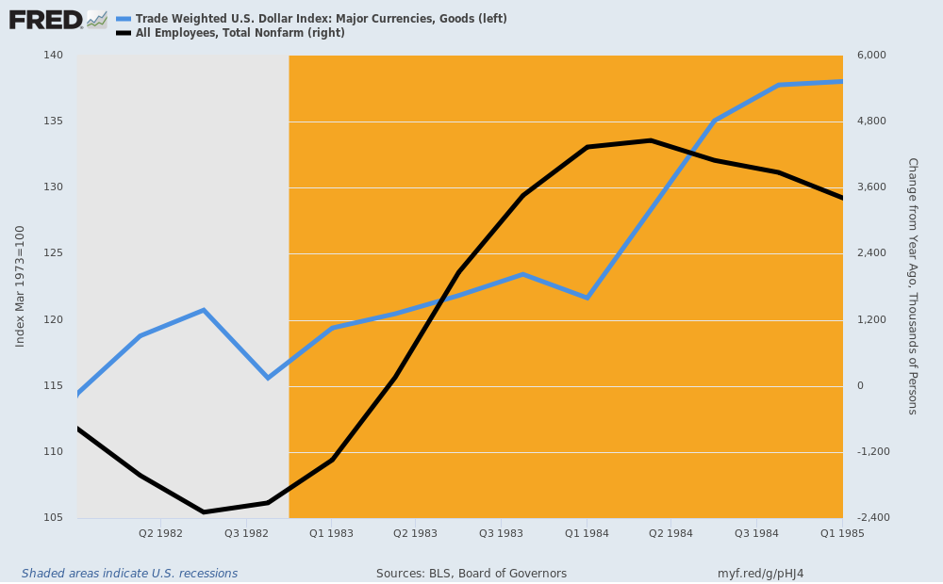
Needless to say, the Reagan landslide had hardly been validated by the Electoral College when Texas Economics struck hard, and in the most novel kind of way.
We recall well the phone call from Jim Baker explaining that the Gipper had decided to make a "swap" in his line-up. Of course, by then we had learned from experience that when Jim Baker said "the President has decided" it was actually he who had done the deciding.
Still, we were fortunate to have been sitting down because the essence of the swap was flat-out crazy. That is, Baker would be moving his Texas Economics brief over to the Treasury Department and the politically inexperienced and utterly tone-deaf Don Regan would become chief of staff.
In a word, Tall Paul Volcker could not have had a more unfortunate land-mine planted in his path. Not only was Jim Baker no friend of sound money, but Don Regan was now right at the Gipper's ear constantly whispering dings against the Fed Chairman.
That was in part because Don Regan had a towering ego and did not cotton to Volcker's unwillingness to kowtow to the former Merrill Lynch stock peddler. But if Regan had any views on monetary policy at all they had been assimilated during his 4-year tenure as Treasury Secretary from his deputy, Beryl Sprinkle, who was an unabashed monetarist and disciple of Milton Friedman; and it had been the latter who had convinced Nixon to destroy the dollar's anchor to gold through the Bretton Woods fixed exchange rate system in favor of freely floating fiat currencies.
As we have documented elsewhere, Friedman's advice had been the greatest economic and financial catastrophe of modern times, and the destructive stagflation and currency turmoil of the 1970s and early 1980s was living proof.
But the Friedmanites were not about to confess error. Instead, they simply became a pack of carping armchair quarterbacks who always found that the monetary aggregates---especially the classic M1 measure---to be growing too fast or too slow at any moment in time.
Furthermore, this was alleged to be the fault of the FOMC and Fed chair, even though it was more than evident that financial innovation, deregulation and globalization of financial flows had weakened the Fed's control over the money aggregates to nearly the vanishing point. So the steering gear connecting bank reserves, which the Fed did control, to the monetary aggregates, which were generated by the nation's 6,000 commercial banks, had become as sloppy as that of an old jalopy.
Moreover, that was to say nothing of the fact that controlling the monetary aggregates really had little to do with sound money and financial stability, and was essentially the Friedmanite route to managing the GDP and its major components. That is to say, Friedmanite monetary policy was not central banking at all; it was just a right-wing form of Keynesian monetary central planning!
In any event, by the 1980s the Friedmanites were lost in the world of dirty floats and fiat central banking that they had naively unleashed at Camp David in August 1971. Their contribution to Fed policy, therefore, consisted of capricious carping and second guessing, and in the new chief of staff they had an aggressive, ego-driven practitioner of that dubious art.
Thus, surrounded by anti-sound money critics, the Gipper fell prey to the odious scheme to trash the dollar that become the Plaza Accord of September 1985. The aim was to slash the dollar's exchange rate against the Japanese yen from 240 per dollar to 150, and to depreciate the dollar by lesser but still large amounts against the D-mark and other stronger European currencies.
Needless to say, this was a Jim Baker/Texas Economics special to which Volcker only reluctantly acquiesced because he really didn't have any alternative. The White House was already threatening to pack the Fed with appointees willing to do its bidding. The photo below famously published at the time told you all you need to know.
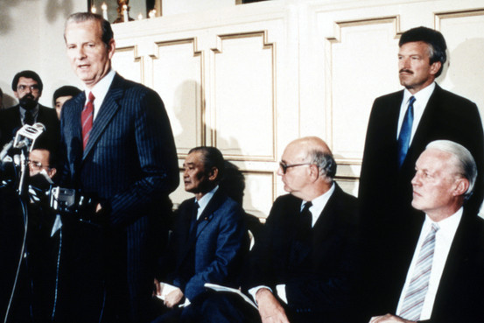
It was Baker who had engineered the multilateral agreement to spend a multi-billion international kitty trashing the dollar, and that was clear as a bell in the press conference photo with Baker at the podium and Volcker slumping in a chair against the wall alongside his Japanese counterpart, who was heading for the wringer of export-dependent Japan's 100% appreciation of the Yen against the dollar.
Years later in an interview, Volcker made explicit what the photo already told you at the time.
Volcker: I was not an enthusiastic proponent of the Plaza Accord. I was not against it, but I was a little fearful. I thought the dollar was going to decline and it was declining on its own. From a central bank standpoint, you're never happy about pushing your own currency down, you think it might get a little out of hand. So we had a discussion about how we were going to maintain or at least avoid a free fall.
Tall Paul got that right at the time, and decades later in the form of his recollection. In fact, traders and speculators had already driven the dollar to its peak at 145.1 on the trade weighted index in February 1985, and it was already down to 130.0 right before the Plaza Accord was announced in September.
But just as Volcker---a market man to the core---had feared, the newly rambunctious pack of global currency speculators, which had been brought into being in August 1971, all did a classic student body left. That is, they aggressively pivoted to selling that which the foolish international conference of financial officials announced they would be selling at the Plaza meeting in New York, and soon King Dollar was in a veritable free-fall.
A year after the Accord in September 1986, the index was down by another 20% to 105.0, which happened to be the value a decade earlier in late 1975 after the recovery from recession. But it kept sliding until it reached 86.0 in December 1987---or 10% below the very "weak dollar" exchange value at the 1979 Carter-Miller bottom that Volcker had been called into to reverse.
So that led to another Jim Baker special---still another international agreement, but this time to support the dollar from below rather than trash it from above. That was called the Louvre Accord, but its significance extends far behind the long-forgotten dollar support mechanism established on an emergency basis at the time.
To wit, these anti-sound money Baker Specials demonstrated quite dramatically that massive central bank intervention in financial markets for whatever reason---
- exchange rate pegging,
- interest rate pegging,
- bond yield suppression,
- wealth effects goosing of the stock market indices,
- yield curve management
- etc.
----spawn an insidious reaction in financial markets that leads to endless mis-pricing and falsification of whatever financial asset variables are the target of the intervention.
That destructive force, of course, is speculator front-running of announced monetary and central bank policies. Indeed, the slow-footed policy officials and apparatchiks are the financial gods' gift to the fast money speculators who congregate in the financial markets and casinos.
Needless to say, then and there (September 1985) front runners learned they could make Eazy Peazy money front-running the policy makers, and they have never looked back.
That's the reason Keynesian monetary central planning doesn't work, and why once again Wall Street speculators are making a killing on the latest iteration of the Fed's "Not QE" money pumping operation.
But long before the present absurd apotheosis, it paved the way for Tall Paul Volcker's ignominious rebuke when he was forced out in August 1987, and when Jim Baker seized upon Alan Greenspan as his replacement.
As we will explicate further in Part 3, Baker was a master politician and powerful assessor of human frailties. So regardless of Greenspan's decades-earlier abandonment of his gold standard views, Baker knew a mark when he saw one.
More than anything else, the nebbish Greenspan wanted to be important and adored by the crowds on both ends of the Acela Corridor. Keynesian monetary central planning afforded him the very route to that end---even as it aborted Tall Paul's short lived effort to return central banking to its narrow remit of supplying reserves and stability to the commercial banking system, as Carter Glass and the founders had intended 70 years earlier.
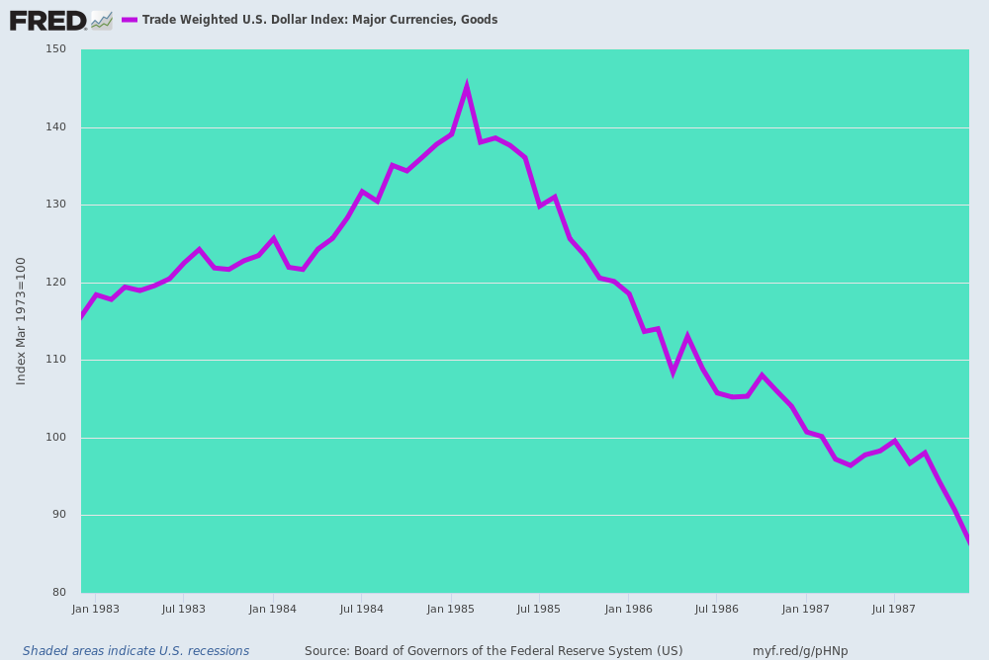

__________________________________________________________________________________

Tall Paul Volcker, The Last Central Banker--R.I.P (Part 3)
From: https://davidstockmanscontracorner.com/tall-paul-volcker-the-last-central-banker-r-i-p-part-3/
Date: December 11th, 2019
By David Stockman. Posted On Wednesday, December 11th, 2019
The Baker/Regan Swap and the turn to Texas Economics was just one of the post-1984 election landslide developments that paved the way for Tall Paul's demise and the subsequent end of Sound Money based central banking.
An even more consequential showdown on Federal deficits and monetizing the public debt came sharply on its heels. That's because after the Gipper's 525-13 Electoral College smash, the California pols in the White House led by Ed Meese and Marty Anderson got to feeling their oats and decreed that no one in the Administration would henceforth dare even utter the word "tax increase".
It was the original "seal your lips" moment, and reflected their fatuous belief that the booming US economy and Reagan's victory was due to the stimulative effects of the huge 1981 tax cuts. In effect, they became born again supply-siders, insisting the Morning in America boom was so powerful that the US could indeed grow its way out of the massive Reagan deficits just like Art Laffer's napkin said.

Laffer Curve Napkin | National Museum of American History https://americanhistory.si.edu › search › object › nmah_1439217
In 1974 economist Art Laffer sketched a new direction for the Republican Party on this napkin.
Laffer was joined by journalist Jude Wanniski and politicians Dick Cheney and Don Rumsfeld. ... Wanniski popularized the theory, and
politicians Don Rumsfeld and Dick Cheney carried it out.
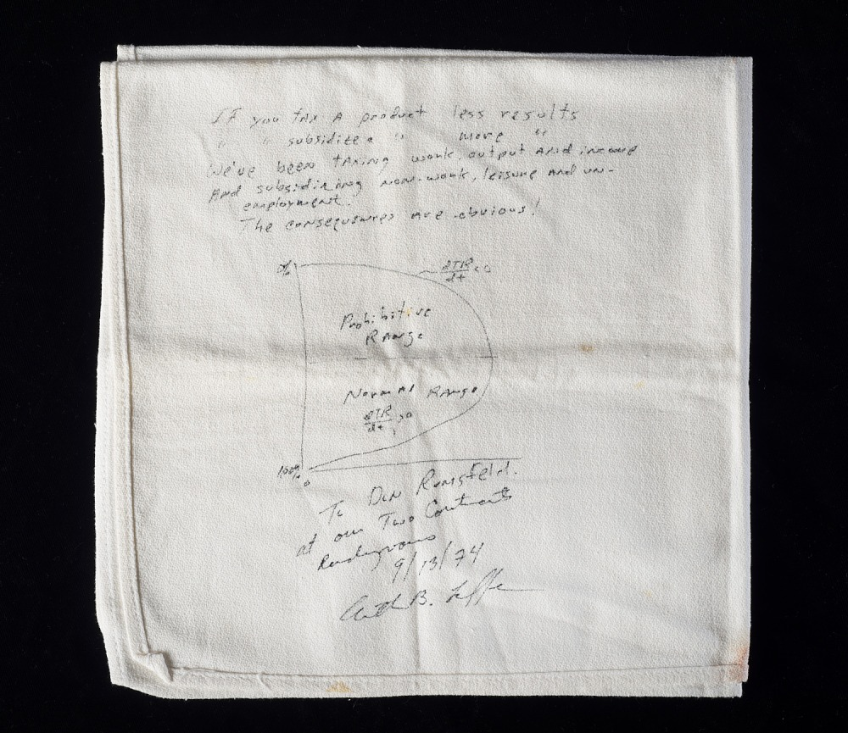

But that was pure fantasy and had already been demonstrated to be economic crankery of the first order.
As shown in the chart below, the original 1981 tax cut bill had essentially doubled down on the Kemp-Roth 30% rate cut. Per the box, the latter would have reduced revenue by about 3.0% of GDP when fully effective, but to get the requisite 218 votes in the Democrat House, there had been a bidding war based on stuffing the business lobbies with so-called investment incentives (10-5-3) and special interest loopholes (ornaments) of every shape and size known to the K-street lobbies.
So when the dust had cleared in August 1981, the Federal revenue base had been shrunk by what amounted to 6.2% of GDP by the end of the decade---a figure that in today's economy would amount to a stunning $1.3 trillion revenue drain. Per year!
Needless to say, no imaginable level of GDP growth was about to close that yawning fiscal gap---even as the spending policy side of the equation had already proved to be utterly impotent.
That is, the Gipper and DOD Secretary Weinberger (with muscular help from the military-industrial complex and congressional pork barrelers) were determined to double the defense budget, while the GOP Senate by a vote of 99-0 in May (1981) had taken Social Security and the other big middle class entitlements off the table.
So there was nothing left to do but recoup some of the massive 1981 revenue drain in order to at least cap the unprecedented eruption of peacetime red ink.
As it happened, Reagan signed three significant tax increases in 1982, 1983 and 1984 to partially off-set the revenue hemorrhage. Yet even after recouping about 40% of the original revenue loss or about 2.5% of GDP (and $500 billion per year in today's economic scale), the Federal deficits remained in excess of 4% of GDP on a permanent basis.
After the 1984 economic boom and election landslide, however, these revenue recoupment bills became the subject of instant revisionist history. They were now denounced by the Reaganite pols and supply-siders as the nefarious work of "tax grabbers" who had purportedly hoodwinked the Gipper and betrayed the Reagan Revolution.
Needless to say, your editor was denounced as a ring-leader of the apostates, but the historical record leaves no doubt that without the three tax increase bills of 1982-1984 there would have been a fiscal calamity of biblical proportions; it would have surely sent interest rates soaring and the US economy back into the recessionary drink where the Gipper's legacy would have ended in tatters.
As it was, despite all the alleged booming growth and 40% drawback of the tax cuts, the public debt rose from $930 billion to $2.73 trillion during the Gipper's final year.
That is to say, the GOP politician who had been the scourge of deficit finance added two times more to the national debt during his eight years than the first 39 presidents accumulated in 190 years.
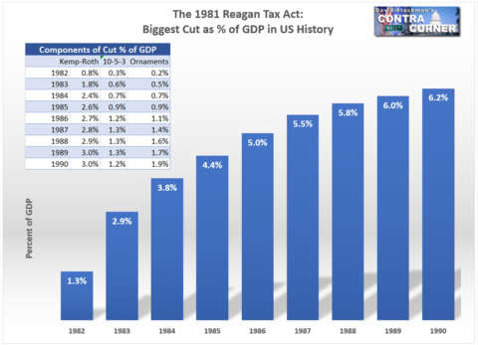
Back in the day, however, the Reagan politicos and their supply-side pitchmen were not about to see it that way at all. Militantly resisting any further revenue raising measures---even as part of a savings package containing equal or larger spending cuts---they guaranteed Washington that would remain locked in fiscal stalemate and that Tall Paul would end-up getting the blame for the rising interest rates and "crowding out" effects that were inherent in the massive Reagan fiscal deficits.
Nowadays, of course, that crucial matter is about as ill-understood as ancient Latin. Three decades of massive monetization of the public debts by the Fed and other central banks have effectively euthanized
- the bond vigilantes and
- the last remnants of fiscally hawkish politicians and
- analysts
alike.
But that doesn't gainsay the crucial events of 1985-1987: They actually shed a bright light on why Volcker can be considered the Last Central Banker and why we have detoured into the dead-end of monetary central planning.
In the first place, it is axiomatic that sustained economic growth requires ever increasing levels of productive capital accumulation---the product of savings and investment. And it is also true that that this growth propellant can falter if private savings persistently weaken or if the available pool of savings is allocated to wasteful investment.
Needless to say, the Reagan fiscal debauch was a case study of the latter. It essentially caused the diversion of the nation's moderate level of private savings into the maw of wasteful government deficits.
In today's world, of course, the connection between fiscal deficits and economic waste is also ill-understood. That's because the addiction to "stimulus" on both end of the Acela Corridor has essentially fostered the canard that since any government spending adds to measured GDP it doesn't matter where it goes---including, presumably, putting government payrollers to work digging holes with teaspoons and filling them back up.
Yet it is an empirical fact that the state sector in modern social democracies including the United States does not accumulate productive investment. Instead, it consumes private savings to fund
- perennial fiscal deficits driven by transfer payments,
- the inherent economic waste of military budgets and
- deadweight losses embodied in domestic pork barrels.
By contrast, the share of funds that go to arguably productive highways, airports, ports and public utilities is a rounding error (less than 2%)--especially in the US fiscal equation because most infrastructure is funded by user fees or private firms, not the government's general fisc.
In any event, during the golden era of American prosperity between 1955 and 1969, a reasonably impressive level of fiscal discipline was maintained, meaning that the diversion of national savings into public sector waste had been de minimis.
In fact, over that 15 year period the Federal deficit (brown line) averaged just 1.2% of GDP compared to net national savings (dark line) from all sectors---public and private--- of 9.8%. In GDP math, however, government deficits are recorded as "dis-savings"---so effectively gross private savings averaged 11.0% of GDP.
This is crucially important because it means that government dis-savings or economic waste at an average rate of 1.2% of GDP absorbed just 11% of gross private savings. All the rest went to productive investment in plant, equipment, technology and the stock of residential housing.
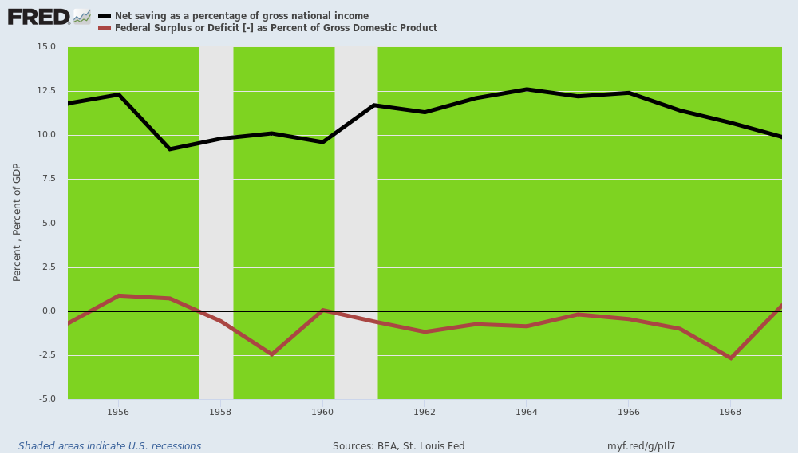
By contrast, during the Reagan-Bush era, government deficits averaged 4.2% of GDP while gross private savings weakened slightly to an average of 8.5% of GDP.
Accordingly, government dis-savings/waste consumed nearly 50% of gross private savings.
Stated different, net national savings or what was left after the government's take fell from 9.8% of GDP during 1955-1969 to just 4.45% percent of GDP for the 1983-1992 period shown below. That is, productive investment from the domestic economy got cut by well more than half.
In the graph below we eliminated the big deficits of 1981 and 1982 because they were largely inherited and the passive consequence of Volcker's recessionary purge, and included the Bush deficits because by then the reining Reaganite orthodoxy prevented Bush the Elder from doing much about the structural deficits he inherited from the Gipper---even after he moved his lips on the matter of tax-raising during the early 1990s.
This is a matter of far more salience than just GDP math. What was happening was that the unprecedented Reagan fiscal deficits were threatening to choke off the very growth boom that had become the Reaganite excuse for letting the red ink run unabated.
By 1987, in fact, there was only one way out---and even that was only good for an interim escape. To wit, the Fed could be forced to monetize the deficits, thereby temporarily alleviating the squeeze on gross private savings and the implicit pressure on interest rates and private investment.
But monetize the debt in wholesale fashion is something that Tall Paul Volcker would not do. Period. Full stop.
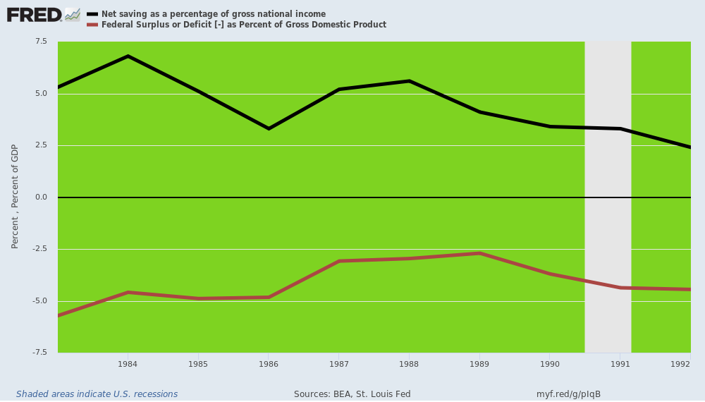
As it happened, the rubber began to meet the road by 1987. In response to Volcker's crushing of inflation, the benchmark 10-year treasury yield (purple line) had subsided from nearly 16% at the 1980 peak to 6.95% by August 1986. Even then, however, the "real yield" posted at a healthy 3.6% owing to a running inflation level (dark line) of about 3.3%.
But a still expanding economy and persistently large fiscal borrowing now generated the classic "crowding out" effect, which occurs in an honest bond market when demand out-runs the available supply of funds. Accordingly, the 10-year UST soared to 9.65% while the running (year--over-year) inflation rate crept up to 4.0%.
But this meant that the real UST yield had spiked to 5.6%, thereby threatening to choke off the Reagan Boom after only a few years of prosperity. By way of comparison, as of this morning's data points the real 10-year yield was -0.55%!
Under those circumstances, Paul Tall Volcker did not hesitate--in both public and private forums---to warn that the fiscal deficit was the culprit and that serious measures----cutting entitlements, curtailing discretionary spending and raising revenues---were urgently needed.
That message, however, was about as welcome at the White House as the proverbial skunk at the garden party. So the California Reaganites in the White House and the Texas Economy partisans at the U.S. Treasury ganged-up: By August, the Last Central Banker was gone, and the era of Keynesian monetary central planning was about to commence.
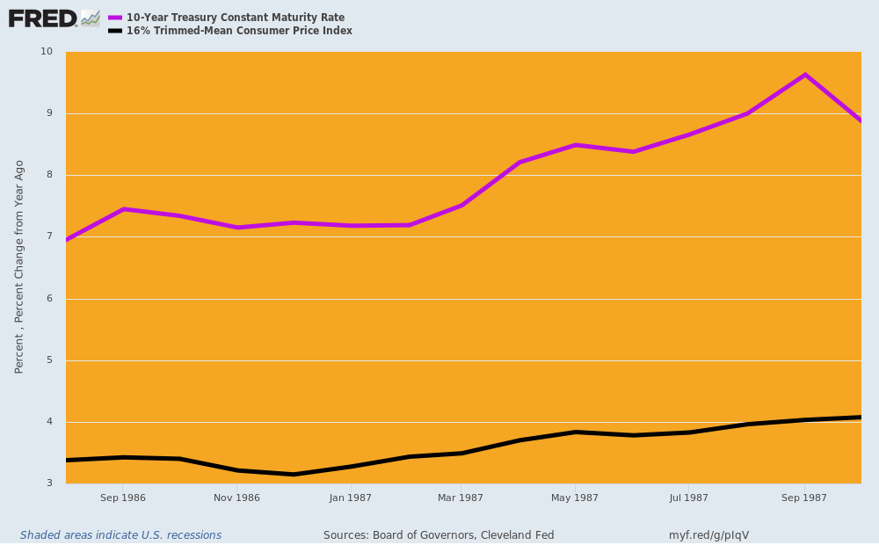
Needless to say, Tall Paul Volcker was not wrong about the outsized Reagan fiscal deficits. They were an imminent threat to prosperity, which was eventually skirted by the even more destructive expedient of central bank monetization of the public debt.
We take up that final chapter in the Volcker saga in Part 4, but here it needs be underscored that there never was a Reagan tax-cut induced boom, nor any acceleration in the trend rate of real GDP growth at all. And there certainly was no prospect of ever growing out of them per Art Laffer's silly napkin.
What actually happened was eight quarters of robust rebound from the deep Volcker recession and from the lifting of the corrosive effect of open-ended, double-digit inflation on business investment and household spending alike. In fact, had the tax cuts really "stimulated" a growth bonanza it would have been back-loaded in the decade when the cuts became fully effective after 1986.
But actually the opposite happened. Inventories which had been violently liquidated during the recession were rebuilt and housing and business investment rebounded after the recovery commenced in November 1982. But it didn't last, and there was no permanent uptick in the rate of GDP expansion, as would have been the case if the tax cut was really the tonic it was ballyhooed to be.
This is dramatically evident in the chart below, where the dotted purple line represents the seasonally adjusted annualized rate of real GDP change for each quarter from Q3 1981, when the recession commenced, to Q3 1990 when the Greenspan recession triggered in.
It was the 5-9% rates of quarterly GDP gains in 1983 and 1984 which gave rise to the Reagan Boom mythology, but the chart makes evident that much of the sizzle was due to restocking of inventories. The counter-part destocking phase is also evident in the same data for the 1981-1982 downturn.
The proof for this is the green line, which represent the year-over-year rate of real final sales growth---a measure which filters out the violent inventory swings and which represents an actual 12-month change, not 90 days annualized.
Thus, at the dark bottom of the Volcker recession in Q1 1982, the annualized rate of GDP shrinkage was -6.3%, but even as inventories were being vaporized, the level of real final sales in the US economy was only down -0.3% from prior year; and even in the bottom quarter (Q3 1982), real final sales had only shrunk by -1.4% from prior year.
Needless to say, the rubber-band worked the other way during the initial 1983-1984 recovery. When the peak quarterly rate of real GDP gain was registered at a sizzling 9.0% annualized rate in Q2 1983, the actual gain was only 3.3% from prior year on the real final sales line.
In fact, the peak rate of year-over-year real final sales gain posted at 6.0% in Q3 1983 and the boom was then all over except the shouting, as the rate of real final sales gain proceeded to steadily peter-out over the course of the decade. By Q1 1987 it was under 3.0% and by the eve of the Greenpsan recession in Q3 1990 it was down to 1.5% versus prior year.---before rolling over into negative territory.
In all, real final sales between Q2 1981, which was the pre-Volcker recession peak, and Q2 1990, which was the pre-Greenspan recession peak, averaged 3.4% per annum.
But that was not a boom and no acceleration from the historic past. Between 1954 and 1969, for example, real final sales grew at 4.1% per annum, or 20% faster over the course of two business cycles.
So what the demise of Tall Paul Volcker actually proved is that it takes both sound money and fiscal rectitude in combination to produce genuinely booming economic growth.
Alas, during the Reagan recovery only one of these conditions pertained, and thereafter the arrival of Alan Greenspan and monetary central planning at the Fed brought about the demise of both.
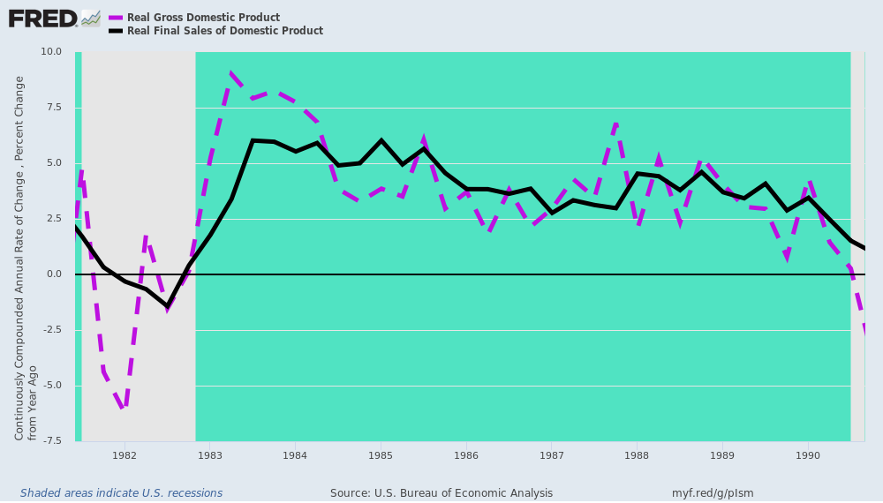
__________________________________________________________________________________

Tall Paul Volcker, The Last Central Banker (Part 4)
From: https://davidstockmanscontracorner.com/tall-paul-volcker-the-last-central-banker-part-4/
Date: December 12, 2019
By David Stockman. Posted On Thursday, December 12th, 2019
There was every reason in the world why Paul Volcker should have been reappointed for a third-term as Fed chair in August 1987. And the fact that he wasn't, made all the difference to the world, as well.
Of course, he had vanquished the punishing double digit inflation that was raging when he took office in August 1979 and thereby paved the way for the Reagan Boom. That should have been justification enough.
In truth, however, Tall Paul had accomplished something of far more fundamental and lasting importance. To wit, he had shown the way back to reasonably sound money and a prudent model for the conduct of the Fed's business in a post - Camp David [last nail in the Gold Standard Coffin –FNC] world where fiat currencies and unshackled central bankers were virtually an existential threat to sustainable capitalist prosperity.
At the political level, he had not flinched when
- homebuilders,
- farmers,
- small business lobbies,
- exporters,
- commodity traders,
- Wall Street speculators,
- virtually all of Capitol Hill and
- the President's own chief of staff
had bitterly attacked his actions.
This steely resolve evinced "independence", of course, but not merely today's superficial palaver about the Fed's supposed insulation from "politics". Volcker's eschewal of "political influence" was far grander and more connected to the very essence of honest central banking.
In a word, Volcker was not in the society betterment business. He did not see the Fed as a de facto political agent tasked with engineering economic outcomes with respect to growth, jobs, incomes and living standards that were purportedly superior to the natural results of the marketplace.
He also did not put much stock in Keynesian macro-models and was deeply skeptical about the Fed's capacity to deliver quantified macroeconomic outcomes---to say nothing of the nirvana of full-employment bedecked with a car in every garage and a chicken in every pot.
And he most certainty didn't think it seemly, appropriate or accurate for the Fed to go around taking bows for whatever economic goodness was perchance embedded in the in-coming data.
Instead, he was about the business of superintending sound money and price stability and fostering healthy functioning and equilibrium in the commercial banking system that the Fed had originally been mandated to serve. Outside of that limited mission, the rest of economic and financial life was up to private capitalism and elected officialdom, as the case may be.
There is no better way to convey Volcker's narrow remit notion of central banking than through his sharply critical views on the Fed's 2.00% inflation targeting. The latter became the subject of fashionable chatter in monetary circles after he left the Fed and then was elevated to gospel under Bernanke and anointed as official policy in January 2012.
But inflation-targeting never, ever would have happened under a Volckerite Fed. Tall Paul knew a rat when he smelled one cavorting among central bankers, PhDs and Wall Street promoters. That is, Volcker knew full well that today's style of inflation targeting from below had no merit in its own right as a monetary tool.
"Would you like some purchasing power haircut with those wages and savings" was not a question which struck him as sensible.
To the contrary, inflation targeting is actually just a thinly disguised pretext for the pursuit of activist Keynesian management of the main street economy in the guise of central banking. In his recent memoir Volcker addressed the matter at length, but it should be understood that his reasoning on this topic was but an application of his overall notion of proper central banking:
.....a remarkable consensus has developed among central bankers that there’s a new “red line” for policy: A 2 percent rate of increase in some carefully designed consumer price index is acceptable, even desirable, and at the same time provides a limit.
I puzzle about the rationale. A 2 percent target, or limit, was not in my textbooks years ago. I know of no theoretical justification. It’s difficult to be both a target and a limit at the same time. And a 2 percent inflation rate, successfully maintained, would mean the price level doubles in little more than a generation.
I do know some practical facts. No price index can capture, down to a tenth or a quarter of a percent, the real change in consumer prices. The variety of goods and services, the shifts in demand, the subtle changes in pricing and quality are too complex to calculate precisely from month to month or year to year. Moreover, as an economy grows or slows, there is a tendency for prices to change, a little more up in periods of economic expansion, maybe a little down as the economy slows or recedes, but not sideways year after year.
Yet, as I write, with economic growth rising and the unemployment rate near historic lows, concerns are being voiced that consumer prices are growing too slowly — just because they’re a quarter percent or so below the 2 percent target!
Could that be a signal to “ease” monetary policy, or at least to delay restraint, even with the economy at full employment?
Certainly, that would be nonsense. How did central bankers fall into the trap of assigning such weight to tiny changes in a single statistic, with all of its inherent weakness?
Indeed.
Actually, the difference between 2.00% and 1.50% on the arbitrary inflation gage called the PCE deflator is pure noise in the scheme of things, and has no relationship whatsoever to the trend rate of growth in output, jobs, incomes or anything else which matters on main street.
That today's monetary central planners have been reduced to counting the equivalent of angels on the head of a pin is evident in the chart below, which covers the span from the official adoption of inflation targeting in January 2012 to the end of Q3 2019.
The red line representing the 16% trimmed mean CPI is as good a measure as any of the defective inflation indices Volcker mentioned above. And it has the added virtue of straining out the high and low outliers each month (always different, not just food and energy) and also measuring some approximation of true health care inflation in the private medical care and insurance markets.
For the period below, the 16% trimmed mean CPI (red line) came in at 1.94% per annum. So if the Fed heads had happened to pick that measuring stick for their inflation targeting---why then saints preserve us if they still would insist that 0.06% is an intolerable shortfall from target.
As it is, they use the PCE deflator, which, if you are looking for an excuse to pump fiat credit into the canyons of Wall Street, has the virtue of way under-measuring inflation. That's because it uses government suppressed Medicare and Medicaid payment rates as a proxy for medical costs, and also because it doesn't even measure price level change over time.
By continuously changing the weights of the items in the basket of goods and services based on the aggregate spending mix of the US economy each quarter, it deflates the nominal GDP at any moment in time, but does not reflect change in the domestic purchasing power of the U.S. dollar, which, presumably, is the point of inflation targeting in the first place.
In any event, the PCE deflator (dark line) posted at 1.38% per annum during the last eight years---a 0.62% deviation from target that the Fed heads have found to be intolerable, even if Tall Paul Volcker rightly questions the very sanity of that inference.
Besides that, the PCE deflator is enormously volatile within the Fed-postulated narrow range of observation owing to the fact that powerful global currents in the commodities and goods markets buffet the prices of these item substantially on a short-run basis.
Since the Fed is in the business of fine-tuning its control dials nearly every month (and between meetings whenever it gets the whim), it looks at the volatile dark line in the chart below (PCE deflator) through squinty eyes and with a secondary gaze upon the purple dotted line.
The latter is the PCE deflator less food and energy, which has the virtue of being less volatile, as well as the vice of excluding a huge chunk of what the main street economy actually produces, stores, transports, distributes and consumes.
As it happened, during the same eight year period the PCE deflator less food and energy posted at 1.62% per annum. So that was a mere 0.38% shortfall, but by the lights of today's monetary central planners it merits the Fed's imminent shift to price level targeting or what has been dubbed "inflation make-up" policy.
That's right. The US economy has been purportedly deprived of the tonic of 0.38% more inflation over 2012-2019, so the Fed is fixing to lather up the printing presses in order to confer said elixir upon main street in, well, what?
The first decade, year, quarter, day or hour after it switches to price level targeting next year? That detail it hasn't yet explained, but the occupants of the Eccles Puzzle Palace will surely have a theory!
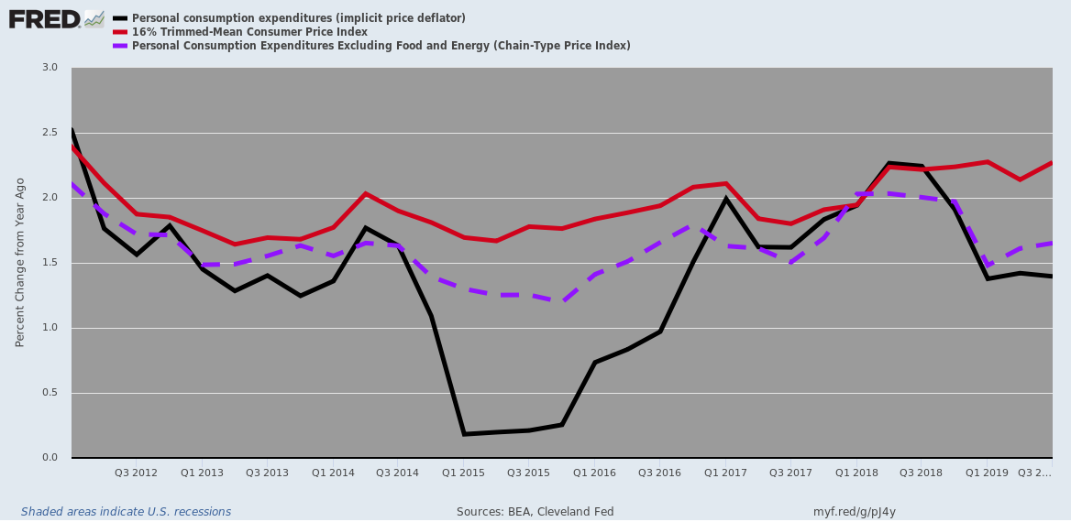
We make so bold as to bold the "theory" word because that's the flaw in the whole matter. Thirty-two years on from Volcker's departure from the Fed, the latter is no longer involved in central banking as it was historically understood and as it might possibly function to do the least amount of harm today.
Instead, on the back of three decades of
- unrelenting mission creep and
- increasingly insular group think and
- abject Wall Street appeasement,
it is now attempting to do the impossible.
Namely, to manage a blooming, buzzing, bucking, bewilderingly complex $21 trillion main street economy, which is intimately and inextricably intertwined in an $85 trillion global economy (the Donald's bumbling drive toward autarky notwithstanding), with crude tools that are barely adequate for the narrow tasks of traditional central banking.
As Volcker further observed in his memoir,
.....herein lies the danger, that such seeming numerical precision suggests it is possible to fine-tune policy with more flexible targeting as conditions change. Perhaps an increase to 3 percent to provide a slight stimulus if the economy seems too sluggish? And, if 3 percent isn’t enough, why not 4 percent?
I’m not making this up. I read such ideas voiced occasionally by Fed officials or economists at the International Monetary Fund, and more frequently from economics professors. In Japan, it seems to be the new gospel. I have yet to hear, in the midst of a strong economy, that maybe the inflation target should be reduced!
The fact is, even if it would be desirable, the tools of monetary and fiscal policy simply don’t permit that degree of precision. Yielding to the temptation to “test the waters” can only undercut the commitment to stability that sound monetary policy requires.
Here's the thing. Everything Tall Paul cogently observed about inflation-targeting is true of every vector of macroeconomic-targeting.
For example, you can't remotely measure labor force utilization accurately in a world of gigs, temps, TaskRabits, Ubers, Grubhubs etc., and that's to say nothing of huge joints like Walmart and McDonald's which schedule work by the hour and 15 minute intervals. So how can you have full-employment targets that are anything more than an arbitrary (and every changing) stab in the dark?
At the end of the day, the road to monetary central planning which was embarked upon when Tall Paul was ejected from the Eccles Building was actually a road to disaster for both capitalist prosperity and sober democratic governance.
Among other things it turned Wall Street into speculative casino which truly does resemble Matt Taibbi's memorable metaphor for Goldman Sachs. That is, a Vampire Squid of financial engineering, inserting its blood funnel into the very lifeblood of the main street economy.
More than all else, however, it brought the end of even a vague semblance of fiscal rectitude in the Imperial City, as we will amplify in Part 5.
Ironically, this baleful outcome was not the least owing to the very new-style Republican hand that tossed Volcker out of the Eccles Building. We are referring to the cockamamie theories of the supply siders and the Milton Friedmanites, who have essentially assured GOP politicians from Dick Cheney on down that deficits don't matter.
What Volcker really stood for was the position that it takes both sound money and fiscal rectitude in combination to produce genuinely booming economic growth and sustainable capitalist prosperity.
Unfortunately, his passing may well symbolize their passing, as well.
__________________________________________________________________________________

Tall Paul Volcker, The Last Central Banker (Part 5)
From: https://davidstockmanscontracorner.com/tall-paul-volcker-the-last-central-banker-part-5/
By David Stockman. Posted On Friday, December 13th, 2019
By August 1987 the cause of fiscal rectitude was already being snuffed out by the very Republican Party that had carried the torch for decades after America joined the ranks of welfare state democracies during the 1930s. But the replacement of the incorruptible Volcker with the weak-kneed, publicity and adoration-hounding Alan Greenspan sealed its demise.
That's because there is nothing more deadly for fiscal discipline than a central bank willing to massively and endlessly monetize the public debt. Quite simply it takes the sting out of financing Big Government honestly via either taxation, which crowds hard upon the voters, or honest bond market borrowing, which crowds out private borrowers and drives up interest rates. [And can be used to pass debt farther ahead, even on to future generations.]
Still, the fact that Greenspan and his heirs and assigns made massive government borrowing convenient and relatively painless is only part of the story. Like most politicians, the post-Reagan generation of GOP officeholders were not completely craven. They did have their reasons, rationalizations and even ideological cover stories for joining the ranks of the fiscally profligate.
The most obvious of these was the supply-sider fiction that tax cuts pay for themselves by stimulating big gains in economic activity. Of course, that might be narrowly true if you are Sweden and taxing 60% of GDP on average and even more at the top.
But the Federal government is a 20% of GDP state, meaning every $1 of tax cut relief needs to generate $5 of incremental economic output in order to break even. That's a tall order as an economic incentive matter, even if you could target most of the tax cut to the top tier of high-powered growth creators---what we infamously referred to as "trickle down" back in the day.
But as a practical matter a major portion of the 1981 tax cut had gone to
- tax loopholes,
- generous depreciation for real estate speculators and equipment lessors and to
- lower withholding taxes among the middle ranks of wage and salary earners.
All were undoubtedly grateful for the tax relief, but it didn't cause their economic activity to spring skyward in the near-term; and, besides, it was paid for on Uncle Sam's credit card----a double shuffle which pushed up borrowing costs for investors and households, even as it reduced their tax bills.
Stated differently, lower taxes are a growth tonic if they are:
- firmly believed to be permanent,
- financed by shrinking the outgo side of the budget ledger, and
- given enough time to work their way into the bloodstream of private sector commerce and investment.
But those "conditions prior" are what got tangled up among the Adam Smith ties which were abundant in the Reagan White House. The focal point was Ed Meese and Marty Anderson, two-long term California-based Reaganauts who were under the baleful influence of Professor Friedman on fiscal matters.
Uncle Milton held that what mattered was spending and the spending share of GDP because as an economic matter government spending inherently channels resources from more productive private uses to less productive---often just plain wasteful---public sector activities. So spending cuts are the only route to fiscal rectitude.
Beyond that, there was a purported political angle. To wit, by focusing on shrinking the deficit and balancing the budget, GOP politicians according to the good professor ended up being unwitting tax collectors for the Welfare State. That is, when push came to shove deficit reduction packages ended up light on outlay cuts and heavy on new revenue extractions.
As an empirical matter, Friedman was right more often than not, but on what really counted he had a giant blind spot. He presumed that the central banks in his brave new post-Bretton Woods world of floating currencies and uncollateralized monies would be run by the equivalent of monetary eunuchs. That is, clear-eyed economic clinicians never tempted to curry favor in the financial fleshpots on either end of the Acela Corridor.
Accordingly, money supply would grow at a low fixed rates (e.g. 3%/year) according to Friedman's monetary rules, and deficit spending politicians would have to face the music of angry constituents whenever Uncle Sam shouldered businesses and homeowners out of the debt markets or forced borrowers to absorb jacked-up interest costs. In turn, the Congress and White House would get the message about taming the spending monster.
Would that it were. But, alas, Friedman never grasped the implications of his own Newsweek columns, which invariably found the Fed's actions wanting---either too hot or too cold when it came to the growth of M1 and his other monetary aggregates.
Yet aside from technical fitments with respect to the linkages between reserves, adjusted reserves, the monetary aggregates and the total GDP, the problem was that no monetary eunuchs ever got appointed to the Fed!
What you got were the likes of Arthur Burns, Bill Miller, Alan Greenspan, Ben Bernanke, Janet Yellen and far worse.
Equipped with the awesome power to print money (technically Fed credit) and relieved of the duty to convert it to gold on demand, the actual members of the FOMC found every manner of reason to wing it without regard to Friedman's rules. And so doing, they crab-walked into public debt monetization because as a practical matter the only way the Fed can get the financial markets and broader economy to march to its tune is to buy Treasury bills, notes and bonds with fiat credits plucked from thin air.
At the moment we are witnessing stunning proof of that cardinal proposition. The monetary central planners who now occupy the Eccles Building have determined that at month #126 of the current business expansion a money market rate of exactly 1.55% day-in and day-out is just the ticket to insure that the American economy brims with maximum goodness.
But the multi-trillion money markets including the giant collateralized funding system known as repo don't wish to cooperate. That's because just since June 30, the US Treasury under the watch of the King of Debt has issued $700 billion of new borrowings. That's $3 billion per day including weekends, holidays and snow days.
Needless to say, this tsunami of Fed paper has caused the balance sheets of the 23 official government bond dealers to balloon big time, sending them, in turn, into the repo market for funding. As our colleague Lee Adler cogently described it:
They know damn well why it happened. The only way the market could finance all that Treasury issuance was through repo borrowing. That, folks, is margin debt plain and simple. The dealers and the banks were buying up Treasury issuance on 90% margin. In September, they [the 23] said, No mas! They’d had enough.
I have shown you this chart before. The [23] banks had been expanding their repo borrowing at an annual rate of an astounding 40% to 60% throughout 2019, and that was on top of a 20% growth rate in 2018. Their repo borrowings rose from the $350-400 billion range in 2017 to $850 billion at the peak in September.
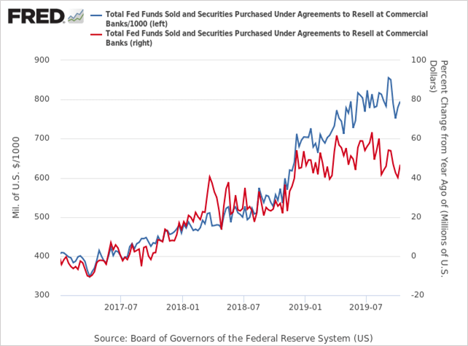
On top of that, of course, the hedge funds and other Wall Street speculators never miss a beat. Seeing the Fed's panicked roll-out of new funding facilities---"not QE" or otherwise---they have gone into overdrive front-running the Fed's renewed spree of balance sheet expansion. That is, they have been putting on structured trades in treasuries and futures expecting their value to be lifted by the Fed's new burst of securities absorption while financing them on 90% margin in the repo market.
Back in the day, of course, no one would have been surprised about the consequence of this massive jam-up in the repo market. The pricing mechanism would have been called-upon to do its job---with sharply rising yields at once discouraging demand and inducing new supply into the market.
Alas, the Fed heads pulled a Capt. Renault back in September, professing to be shocked, shocked when term repo rates spiked to 10%, and are still posting at 3-4% for term borrowings across the year-end "turn".
Needless to say, these spikey overnight and multi-week trades between consenting adults have not been permissioned by the Fed, and that it cannot abide. So it has been mounting ever larger repo facilities and T-bill purchases for the purpose of smashing yields with virtually open-ended demand for repo collateral, thereby forcing traders to toe the mark exactly at its target policy rate.
Still, this past week told you all you need to know about why today's Fed has nothing to do with central banking of the Volcker vintage. It actually announced that through year-end it would be injecting upwards of $500 billion of new credit into the markets through multiple fire hoses including,
- $150 billion of overnight repos;
- $330 billion under nine new term facilities; and
- $60 billion or more of T-bill POMO purchases.
As Zero Hedge noted, upon the full execution of this monster liquidity injection in early January, the Fed's balance sheet will have recouped all the QT sales it initiated last year, and then hastily terminated, far earlier than planned, during August.
That's right. When Bernanke drove the Fed's balance sheet from $900 billion in August 2008 to a peak of $4.5 trillion after several phases of QE, it was solemnly insisted that this was an extraordinary measure enacted under what amounted to the 100-year flood conditions of the 2008 financial crisis, and that it would normalized after the US economy and financial markets regained their footing.
The longest economic expansion history, the lowest U-3 unemployment rate in 50 years and an S&P 500 index that stands in the nosebleed section of history at 4.6X the level of March 2009 would presumably signify footings regained.
But as evident in the chart, having rolled back the Bernanke balance sheet eruption to $3.8 trillion by mid-2019, the Eccles Building has turned tail and run. Based on this week's planned $500 billion liquidity injection, the Fed balance sheet will be pushing $4.6 trillion shortly after the turn of the year.
This also means that by Jan 14, the Fed's balance sheet would have grown by a cumulative $365BN
- in "temporary" repos, and together with
- the expanded overnight repos, and
- the $60BN in monthly TBill purchases,
and by mid-January, the Fed's balance sheet, currently at $4.066 trillion, will surpass its all time high of $4.5 trillion!
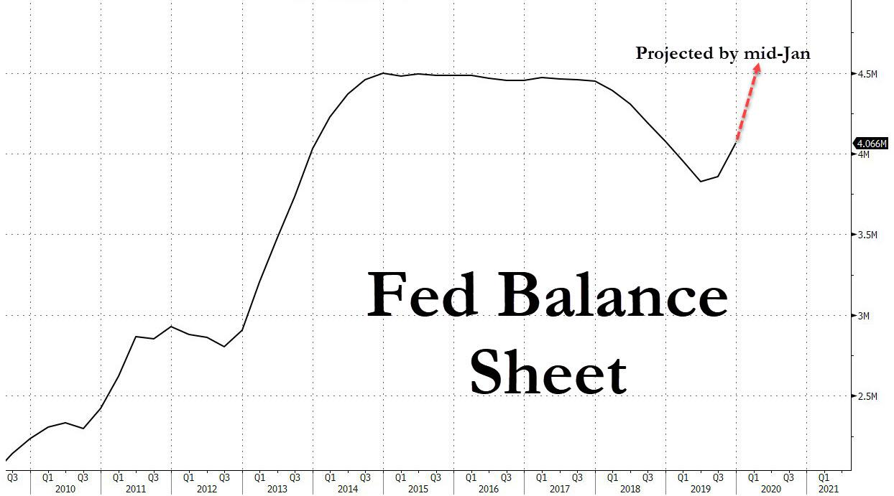
Needless to say, this isn't central banking. It's out-of-this-world financial price control predicated on the false theory that the performance of the entire main street economy can be fined tuned to the Fed's inflation, employment and other macroeconomic goals based on tweaking money market rates by 25, 50 or even 100 basis points.
As we'll elaborate further in Part 6, the occupants of Volcker's Fed have tumbled into a deep rabbit hole in feckless pursuit of Keynesian macroeconomic management. Under current conditions of massive demand for funding, their current 1.55% policy target is absurd.
The latter is of no use to
- auto loan borrowers,
- credit card users,
- small business borrowers or even
- corporations seeking term loans for productive investment.
In truth, the Fed's money market peg is of value only to Wall Street carry-trade speculators and stock market gamblers operating on margin and options.
Nevertheless, the brute force of liquidity injections which are being made in order to peg cheap gambling stakes for Wall Street do have exactly the purpose that Volcker strenuously opposed and for which he got himself fired 32 years ago.
To wit, the Fed is massively monetizing the Federal debt, and at a time so very late in the cycle that even JM Keynes himself had argued for fiscal prudence and balanced budgets.
So Pivoting Powell engaged in outright prevarication at this week's post-meeting presser when he described the rationale for the Fed's $500 billion liquidity bomb:
..... the purpose of all this, let’s remember, is to assure that our monetary policy decisions will be transmitted to the federal funds rate, which in turn affects other short-term rates. We have the tools to accomplish that and we will use them......The purpose of all of this is not to eliminate all volatility particularly in the repo market.
Absolutely not!
As Lee Adler further reminded, the Fed is now engaged in the most egregious acts of public debt monetization in is entire history:
No, the purpose is to absorb enough of US government debt issuance to keep rates down. As of right now, so far that has meant 90% of all new issuance. The Fed is effectively monetizing the US government debt!
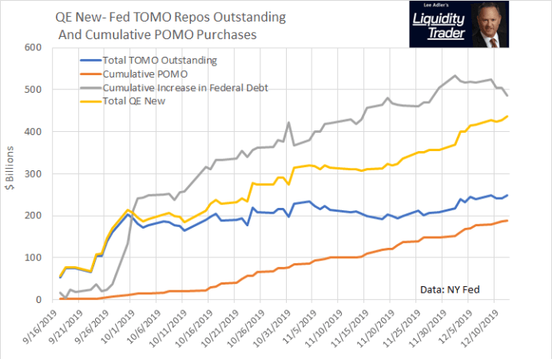
Powell:
The truth is, the post-Volcker Fed have been massively monetizing the public debt for three decades, but has gone into veritable high gear since the September 2008 crisis.
As shown below, between 2007 and 2018, the Federal deficit has averaged 4.8% of GDP---even as the private savings rate has dropped to just 6.5% of GDP.
What this means is that for the entirety of the present so-called recovery, Uncle Sam has been absorbing fully 74% of available domestic savings from households and businesses (retained earnings) combined. And it also means that net national savings has shrunk to a mere 1.7% of GDP.
Recall that in Part 2 we presented this same chart for the golden era of American prosperity between 1955 and 1969. Back then, federal deficits (dis-savings) averaged only 1.2% of GDP while private savings amounted to 11.0%.
Accordingly, Uncle Sam absorbed only one-tenth of gross private savings, meaning that what was left--- net national savings available for private investment and growth---amounted to 9.8% of GDP or nearly 6X more than during the last decade.
With these kind of metrics the halting, low-growth recovery of since June 2009 would have been stillborn long ago. It was only the Fed's massive injections of fiat credit into the financial system that has staved off the day of reckoning.
But it has done so at a staggering cost. To wit, hideously inflated financial markets that are set up for the Mother of All Crashes, and a fiscal equation which is so widely out of balance that a politically viable solution is nearly impossible to imagine.
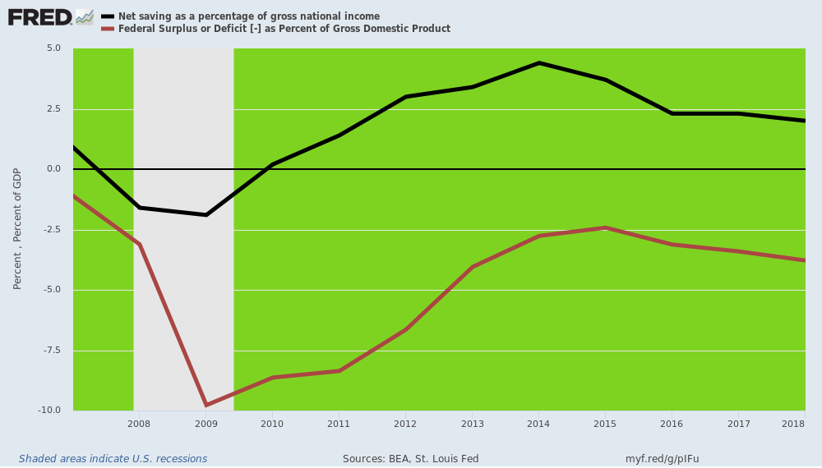
__________________________________________________________________________________
END

That is, Ronald Reagan's.

